**Name – Mujeeb ur Rahman Khan**

**Batch - B**

**Roll No - 37036**

**Class - TE IT B**

**Assignment No.2**

**Title :**

B] Create Docker Container Environment

**Code :**

1. **docker --v**

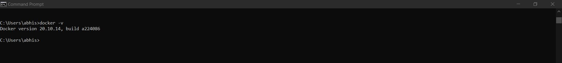

1. **Docker --help**

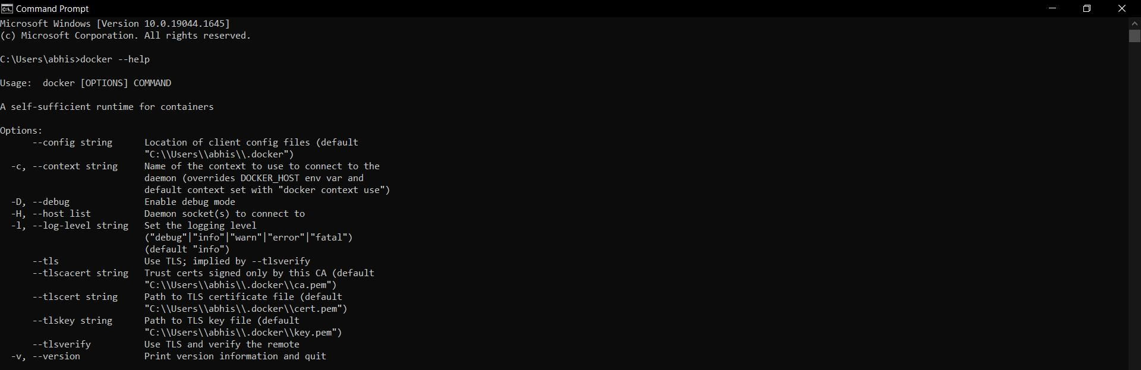

1. **Docker pull ubuntu**

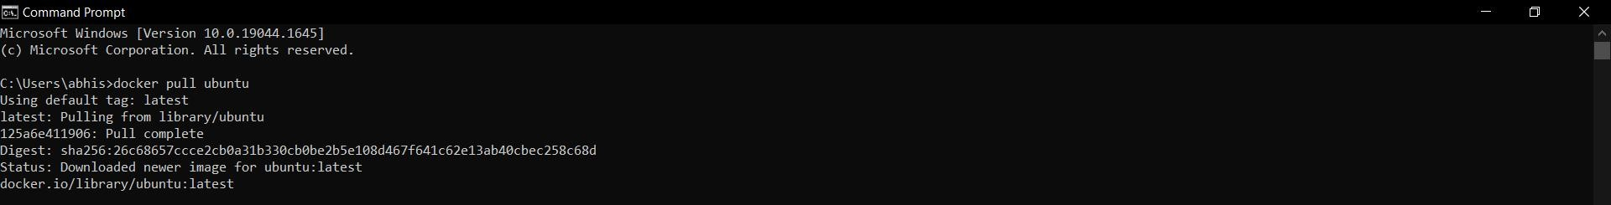

1. **Docker run hello-world**

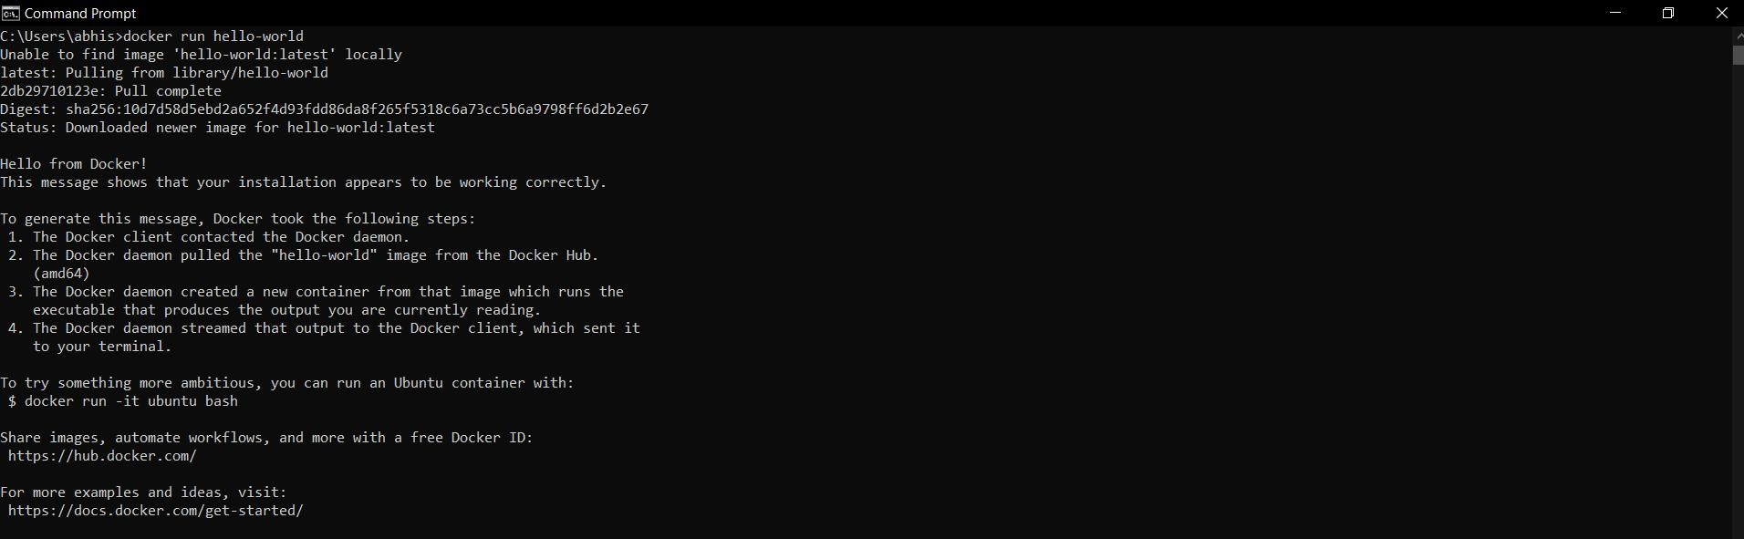

1. **Docker ps -a**

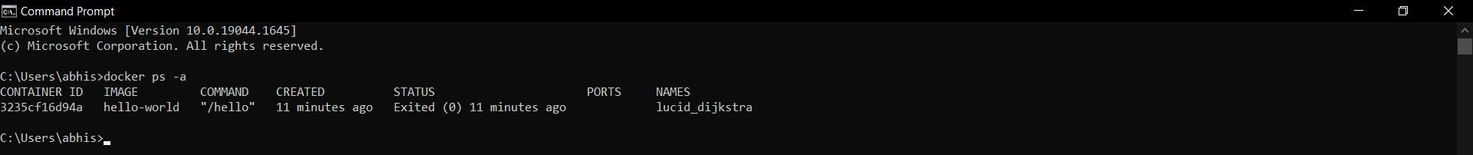

1. **Docker image**

